[See individual schema for citations for internal models]

- Using a modular, OOD approach, mostly inspired by the BOD schema developed by Joanna Bryson, amongst others, including Ronald Brooks’ Subsumption Architecture.
- Simulation is a “model-based reactive agent” (Russell & Norvig). It uses modular, atomic behaviours in conjunction with sophisticated contextual planning algorithms to create reactive behaviour.
- It does not use complex AI methods such as search. The BOD schema has no place for search, as it is often overly complicated, slow, resource-heavy and unreactive. By using BOD’s authored, iterative approach I retain control over my character, create complexity, avoid ‘dithering’ behaviours from insufficient algorithms. Reactive architectures are reactive, responsive, can deliberate and have explicit goals; all suited to believable characters.
- However, it does have internal state, memory and internal models. This is partly to primitively explore my ideas surrounding autocosmics and the character as an environment (both internal and external). I believe I have struck a balance; the system is still simple enough to construct, tweak and understand, while allowing for more complex behaviour which will not be repetitive, which will change over time and adapt to the user. The agent is still reactive, however. I am heavily influenced by the mechanistic, ethological approach of biosemiotics, and its related fields, as a juncture between internal state and reactive architectures. Bryson is not against modelling and consciousness if the creature needs to learn and change, and the environment is bounded and the rate of learning is very bounded. The installation environment, and the limited mental functions of the creature, will ensure this.
- I am also interested in seeing how such systems can degrade in such a way that gives rise to autocosmic sympathy; how to turn the frustration and ‘black-box’ corruption of the creature-as-machine into a autoscosmic sympathy, sense-made through prolonged imaginative interaction.
- I have kept the internals as simple as possible. I hope that its personality, not created as a module but infused throughout its construction will allow people to fill in the gaps, to seek patterns and understanding, as they would in any complex systematic environment.
- Many ideas taken from AI approaches, particularly those which privilege the human. Game AI often uses BOD or a form of modular, reactive intelligence.
- Not a rigourous approach; I am bringing together lots of ideas as an artist, not necessarily elegantly, but in ways which suits my ends for this particular character. As Balkenius warns against, I am not seeking a one-size-fits-all approach to the AI of my creature, or attempting to define everything in a few simple principles. I hope that the relatively complex systems interacting in lots of ways (all interrelated, intereffective) that have simple outputs will make some sense in chorded form, and provide some characterisation, as well as providing a methodology, rather than a technology.

——————————————————————————————————————————————————

BOD

- Bryson’s Edmund architecture preceded BOD.
- Developed of a “modular rather than monolithic” cognitive architecture for virtual and robot agents by Joanna Bryson at MIT and Bath University, as well as elsewhere. It is an “organisational structure based on biological precedent”, an important point for my animal-focussed design philosophy.
- “Decomposition of intelligent behaviour into easy-to-program modules.”
- “Pursues a set of goals relatively autonomously, responding to the challenges and opportunities of dynamic environments that are not fully predictable.”
- A modular approach to designing and building agents, either software-based or robotic. Read Bryson on modularity, her on evidence of modularity in organics and her definition of modularity, as well as a general definition.
- Heavily inspired by O-O-D, BBAI, Colony Architecture , Multi-Agent Systems, theories of emergence and entity-component systems. In these fields, I’ve also looked at Herbert the Robot by Connell (see comment) and Braitenberg Vehicles (see comment).
- As opposed to internal-state-model AIs, BOD agents are reactive rather than deliberative. They contain absolutely no search whatsoever.
- Always designed by hand iteratively, by human beings.
- Bryson admits that this model is based on a direct observation of how nature works in practice, linking her to ideas of character as environment, authorship and interpretation/impressionism.
- BOD agents are a compromise between purely reactive agents and full-internal-state learning-and-reasoning agents.
- The key is to create believable behaviour by separating the flow of data (input and output from behaviours) from the organisational control, and taking into account not just internal or external factors, but both.
- Composed of POSH plans and Behaviour Modules which work in tandem, parallel and opposition to produce an overall behaviour, which “at any given moment is a choice of context, a focusing on a particular set of capabilities.
- (Parallel, Ordered, Slipstack, Hierarchical) Plans are reactive plans (a form of action selection) in which hierarchies of goals and drives compete for primacy in a changing, contextual, non-deterministic environment. The plans determine which behaviour modules run and when, using a combination of the current state of the outside environment and the internal state and goals. This latter stabilises ‘dithering’ between rapidly changing states in the world. This is much better than other action-selection types, such as environmental determinism (if something is in a particular state, do a thing) finite-state machines (states change depending on situations, with different states allowing different actions) and basic reactive plans (which always react to the outside world, sometimes in different ways depending on the situation). POSH allows different combinations of factors to be reacted to in different ways, at various different rates of update, including push, pull and event-driven and other.
- As reactive plans, they have several fail-safe techniques built in to allow a continuous, harmonious and realistic/believable experience to take place when observing an agent; this includes expiry elements to stop looping behaviours, default outputs for all behaviours to prevent halting bugs and randomised heuristic leaps to other behaviours if a particular solution to a goal cannot be found, in order to ‘jump-start’ the creature’s behaviour (a form of annealing).
- They are an example of subsumption architecture, in that different goals and priorities have different weights and importances and can suppress those less-important whilst running. This is the Slipstack Hierarchical part.

The plans take three main different architectures for activating behaviours:

Drive Selection: high-level goals which tend to remain stable:
Competences: if-else actions which are contextual;
Action Sequences: reliable, linear and reactive behaviours.

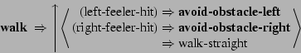

A single agent can have multiple plans, each running many different behaviours in parallel.

——————————

Behaviour modules are self-contained micro-programs, or primitive algorithms. Each one handles a particular task; that might be an external action or may instead be long-term calculation, running in parallel with other behaviours. They are, ideally, black boxes; only their outputs can be accessed by the POSH plans or other behaviours, in order to promote ‘cleanness’ in the code and a lack of interdependency.

Behaviour modules promote a modular identity for an agent; each “encodes [the agent’s] experience and memories” in part, and in working together they display, adapt and update that identity. As semi-autonomous modules, each contains their own perception, action, learning and memory; no state is stored centrally.

They are, in essence, black boxes: “behaviours have no access to each other’s internal state, but can monitor and/or alter each other’s inputs and outputs”.

Importantly, behaviour modules should be atomic - they should not themselves be composed of further, smaller modules nested within them.

——————————

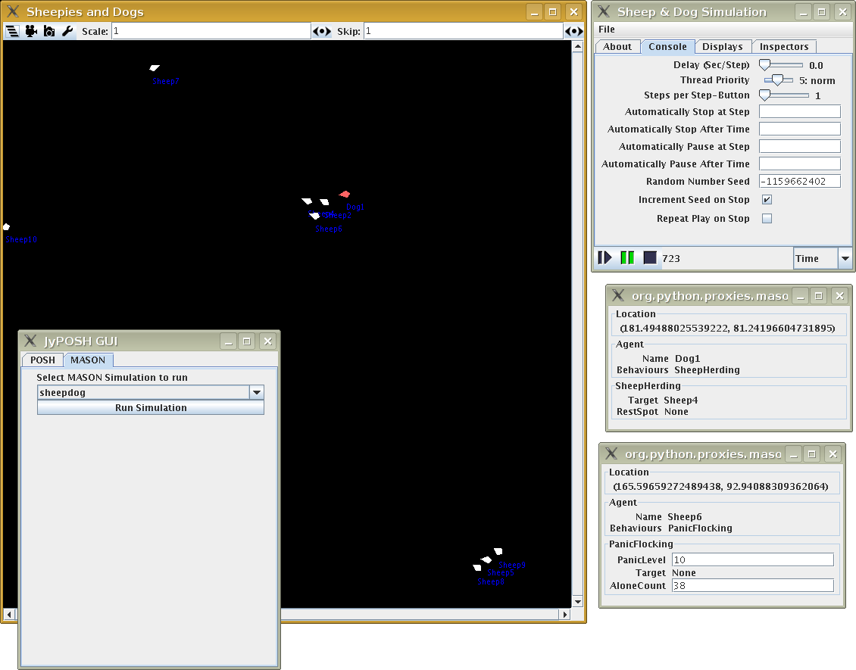

Bryson’s main implementation, apart from a rather classical sheepflock/sheepdog dynamic, is to program a bot for Unreal Tournament, a navigational agent in a limited-but-non-deterministic environment that has been quite successful; demonstrating multiple goals simultaneously, showing a “strong modular composition”.

——————————-

BOD agents are iteratively designed, and this is an approach that I am taking with my godlet. The process is as follows:

“Decompose” the ‘platonic’ agent into a series of desired behaviours or actions on paper. I am taking a writerly approach to this with my micro-narratives.
Group, prune and turn these narratives into primitive, atomic behaviours.
Code behaviours, test, ”guide and prune”, add and augment as necessary, in cycles. It is important to simplify as much as possible as one goes, slowing the exponential growth in complexity as new features are added.

However, as Bryson herself notes, “although behaviour modules are themselves definitionally easy to create, engineering the interactions between behaviours has proved difficult.”

———————————

BOD has proved an excellent starting point for my godlet which is easy to understand and which fits many of my ideas about the creature’s fiction. I particularly like the temporal element to it; in that all the structures are about update schedules. This is important to the strong temporal element in the project itself (chronemic), throughout its various media.

I will, however, be adapting its precepts to my needs, as it is important that I am creating a single, platonic character, not a system for characters: I will adapt my creature’s architecture to the fiction, and not the other way around.

I’m also concerned about there being no centralised internal model at all; how might an agent of Bryson’s have superstitions, beliefs, doubts? All of these are built on discrepancies between the outside world and the interior model. I suppose that behaviours could feed false data to the plan, or the sensors to the behaviours, or the plans to the actuators. Would this have the same result? Are memories and internal plans behaviours in and of themselves? Are the creature’s memories stored, quite literally, in its bones? This might help with my biological metaphor.

——————————

Bryson was influenced (and cites) the slightly-earlier Ymir architecture by Kristinn Thorisson at MIT. It is a modular system for creating real-time, organic, fluid interactive agents (what Thorisson calls “full-duplex”). It takes in lots of different inputs through sensor fusion simultaneously and incrementally and provides corresponding multifarious, simultaneous output. The output and input are incremental, meaning that micro-reactions and micro-sensations occur constantly, building into a more complex, emergent sense/act cycle, and these inputs and outputs work together simulataneously as well, creating seamlessness. As Thorisson says, “Time should be an explicit part of the architecture’s structure and internal data.” This is a large part of my project as well. It allows any action to be stopped almost-instantaneously with a command, even the low-level behaviours.

The architecture is more complex than that of BOD, consisting of perceptual modules, decision modules, blackboards and knowledge bases, arranged into layers; the Reactive Layer, the Process Control Layer, the Content Layer and the Action Scheduler.

Thorisson created a reactive, virtual humanoid agent called Gandalf using this architecture that could interact multimodally (that is, through speech, gesture etc.) with a user to take them on a virtual tour of the solar system. This agent looks at objects in the room, gestures with its hand and acts on a more-or-less human timescale of task and space recognition. It is an interesting model for knole to consider.

————————————————————————————————————

Tweening

This is, basically, fuzzy interaction; making sure that there are smooth, organic transitions between states to give the appearance of responsive functionality and, in the case of agents, believability. Often, when computers break, they just break; it is a binary dropoff that is very jarring. Even when humans go wrong, as delineated in the Dartmouth Proposal, their subsequent actions ‘almost make… sense” - their actions are not robotic, stiff or just stop abruptly, but their behaviour might be a little strange. This is better than just stopping, and in agent design tweening states are imperative to give a believable sense of life.

Chording

A concept (which is almost certainly well-established under other names) which relies in combining different data streams, variables and other qualities to produce unique results in context. Like a chord is an emergent sound from individual notes, so too can to different variables, images, and otherwise produce something new from their temporal, spatial and informational juxtaposition. It is related to sensor fusion, but is subtly different in that the fusion changes the result.

Layers

An important concept both front and back of the creature’s design; a modular approach to cognitive and biological architecture. Applies to the creature’s anatomy and its mind. Layers are groups with ‘depths’ (either spatial or conceptual) with limited interaction between each layer. Linked to the idea of neighbourhoods (Moore and von Neumann) from cellular automation, subsumption architecture and all across computer science, especially in game AI. It will be important to the BOD design to layer the creature on several planes - visually, by behaviour (in the POSH plans), and so on.

Swarm & Flocking

A computational technique most clearly seen in cellular automation; small, simple individual ‘agents’ all act in a space according to a limited set of rules to produce “unexpected behaviours”. A performative, paracosmic ideal in computing; simple rules produce the appearance of complexity. Can be used in almost any sphere of computing to produce similar results.

Knowledge Representation

How to get subjective ‘world’ knowledge into a form that a computer can use, through simplification, division, abstraction and conversion, what can be called ontological engineering. As nucl.ai calls it, “modelling information about the world.” Difficult when input is extremely qualitative such as audio, image or voice. In this approach there is always a question of granularity; how much detail do you model? A KR system also needs to be able to handle uncertainty and exceptions, as well as leaving gaps in the data structures for new information and later modification.

This is something that I think is too important to ignore for my creature, and could perhaps be used in limited, seamless manner (or perhaps in an illusory manner). Image recognition, in particular, is important.

Multimodal Sequential Emotional Expressions

Developed by Sylwia Hyniewska during her time at Bath University. A theory of emotions expressed rather than felt. A performative extension of Leon Watts’ work. Emotion as “a dynamic episode that produces a sequence of response patterns on the level of gestures, voice and face”. Supposed to move away from solely facial expressions and into wider bodily expressiveness, but will be useful for modular facial design and creature-as-environment theory; the creature’s entire biological self will be able to change to respond to emotion. ‘Micro-expressions’ from different body parts “arranged [over] time”. TIME, linearity and sequence are key concepts here. Each expression is constrained in terms of: a) time taken; and b) contextual activation. A key example of chording.

Learning

“Extending the reach of the designer into unknown” (Russell & Norvig). A machine updating its internal structure based on novel input and then recombining it with existing or other inputted knowledge to produce new behaviours. Through observations of regularity, constraints on what is to be learnt, finding the nearest example from the internal library that shares the most attributes, or through reinforcement, inferences can be drawn which can be used in future distinctions. This is an example of applied learning, or bootstrapping.

Turing Machine

A hypothetical machine described by Alan Turing in Computing Machinery and Intelligence and now the theoretical basis for most modern computers. Using a set of rules (in other words, an algorithm) a set of outputs can be determined from a set of inputs. This allows for simulation, programming, imitation of other machines and emulation.

PAD Model

A model of emotions by Mehrabian and Russell in the mid-70s. It uses three numerical, fuzzy values (Pleasure, Arousal & Dominance) to represent all emotions. P represents how nice or nasty and emotion is, the A represents the energy of the emotion and D represent how dominant or submissive the emotion makes one feel. Their values can be floating-point and theoretically infinite or limited to just a few scalar values.

Heuristics

As the creature is biologically inspired, seamlessness is more important than 100% correctness. Educated guesses and estimates (or, for a formal definition, “the relation of current state to final goal” (Russell and Norvig) that allow decisions to be made (rather than ‘cold’, random decisions with no data) that are ‘good enough’ by relaxing the constraints of a problem. Heuristics can be local or global (I.e. by how much data and foresight the algorithm has access to). This is also related to Herbert Simon’s bounded rationality, an idea put forward in Models of Man. In it, he states that human beings are not perfect decision-makers, and the possibility space of their decisions are constricted, or deliberately constrained, by limitations in the environments, past regularities in the space, patterns and time limits. This leads to satisficer decisions, or “good-enough” decisions. This could be applied to AI directly, or more generally to paracosmics and superstitions, which are satisficers for the complexity of the world around us; this has been phrased critically as human beings being less-than-optimal decision-makers; though the argument can be made that our satisficer tendencies often lead to us making better decisions more quickly than by taking the slow, completist rational route (Gerd Gigerenzer).

Agent

See Russell & Norvig’s definitions: utility, reactive agent, reactive agent 2, model-based agent and goal-based agent.

Valence

A term borrowed from psychology to describe the pleasantness or unpleasantness of a consequence or emotion. It can be applied to decision-making, emotional expression, norm agreement or violation and many other factors in agent action selection.

Fuzzy Logic

Neat logic composes of definite numerical or binary values that are absolute; they cannot be degraded in any way. Fuzzy logic, used for non-binary concepts such as belief, probability and utility, uses floating-point numbers to create degree values I.e. degrees of true or false along a scale.

Ontology

Generally, a set of meanings, and terms, that relate to one particular domain (jargon, technical language etc.) The term is often used in AI to mean a way of classifying things internally in an agent (as in Russell and Norvig).

Simulated Annealing

Casting net wide in terms of leaps of exploration, then focussing on a local maxima.

Qualitative Physics

Reasoning about things through comparison to each other, not through numeric values or detailed equations.

Reinforcement Learning

A way of teaching a machine by tagging actions as either good or bad; through repetition, an “optimal policy for the environment” is learned.

Factoring

Decomposing elements into blocks or ‘templates’ that can be recombined in many different ways. Used a lot in Game AI.

Event Calculus

Turning events into objects with qualities.

Probability

A heuristic measure of likeliness. I have encountered them in Bayesian Networks (the probabilistic relationship between all states (a “complete model”) in terms of cause, effect and influence) and Markov Chains (a similar concept: chains of states in a state space with probabilities of moving between those states, usually expressed as a table of all possible moves (a transition matrix), without memory of past events or changes (the ‘Markov property’). Often used for modelling real-world events, and probabilities can change to allow for unpredictable change in systems).

Randomness (Stochastics)

Though it must be used with care, randomness is important to represent the illusion of organic deviation, of biology, and to introduce surprise to an algorithmic narrative.

Discrete State Machines (FSMs)

Introduced to me by Turing - a machine or agent with a certain number of states, and a certain number of transitions between those states. A basic idea of computing and AI.

“Strong” vs. “Weak”

“Strong” AI is mostly theoretical; it involves the creation of human-level artificial intelligence in the truest sense, with general application in every domain of life. “Weak” AI, the domain of most AI scientists today, is AI that has a specific domain and task. This focus on the practicality of weak AI (after the failures of early utopian AI experiments) has led to the fragmentation of the field into numerous sub-disciplines, each a specialisation of the AI principle. John Searle invented these terms as part of his ‘Chinese Room’ argument.

Expert Systems

A limited AI that is deployed for one particular task. In a way, the creature is both general and expert; that is, being expert at being itself.

Heuristics

As the creature is biologically inspired, seamlessness is more important than 100% correctness. Educated guesses and estimates (or, for a formal definition, “the relation of current state to final goal” (Russell and Norvig) that allow decisions to be made (rather than ‘cold’, random decisions with no data) that are ‘good enough’ by relaxing the constraints of a problem. Heuristics can be local or global (I.e. by how much data and foresight the algorithm has access to). This is also related to Herbert Simon’s bounded rationality, an idea put forward in Models of Man. In it, he states that human beings are not perfect decision-makers, and the possibility space of their decisions are constricted, or deliberately constrained, by limitations in the environments, past regularities in the space, patterns and time limits. This leads to satisficer decisions, or “good-enough” decisions. This could be applied to AI directly, or more generally to paracosmics and superstitions, which are satisficers for the complexity of the world around us; this has been phrased critically as human beings being less-than-optimal decision-makers; though the argument can be made that our satisficer tendencies often lead to us making better decisions more quickly than by taking the slow, completist rational route (Gerd Gigerenzer).

Types Of Agents (From Russell & Norvig)

Model-Based, Goal-Based Agent (Essentially what the creature is)

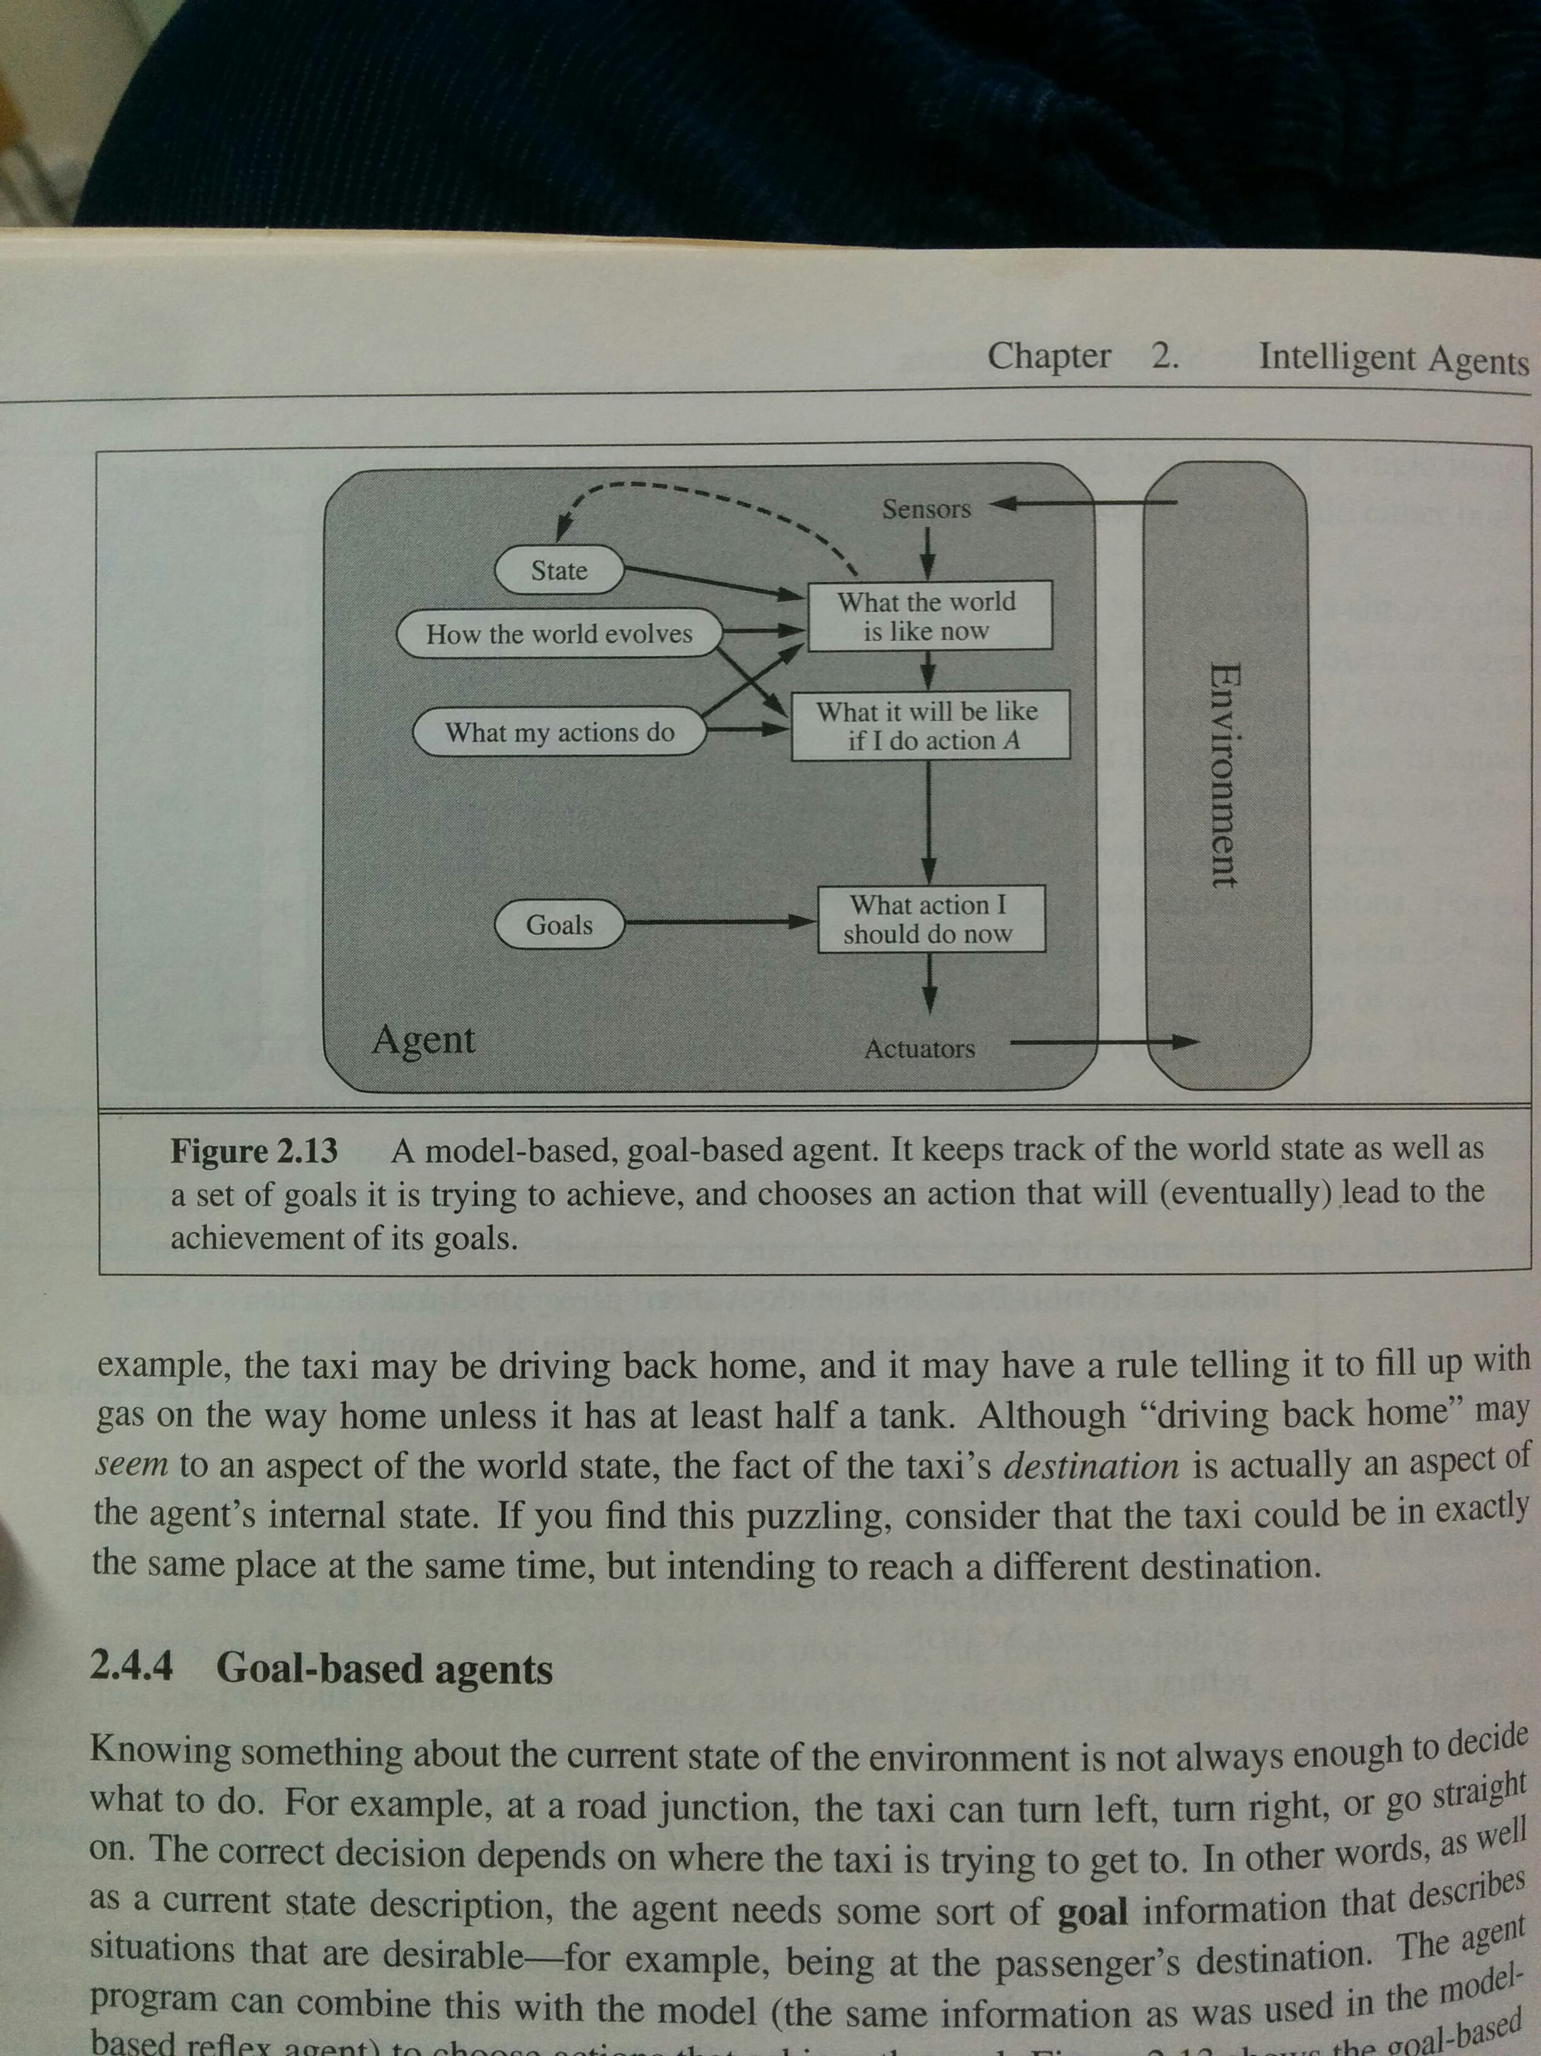

Also could be seen as a model-based reflex agent.

